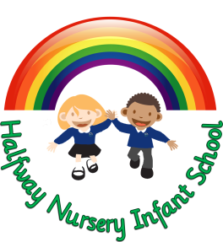

APPLICATION FOR HALFWAY NURSERY

Halfway Nursery Infant School
Station Road
Sheffield
S20 5GU
Tel: 0114 2470564
Email: enquiries@halfway-inf.sheffield.sch.uk
`

APPLICATION FOR NURSERY PLACE
Please complete all sections
Child’s Full Name

Date of Birth

Male or Female
Address
Post Code
Email Address

Contact 1 (Name)

Contact 1 Telephone Number
Relationship to Child
Contact 2 (Name)

Contact 2 Telephone Number
Relationship to Child
Any Siblings (please give DOB and school attending (if applicable
Is your child toilet trained, give details if not

Does your child have any medical needs or any allergies we need to know about
Signature

Date Completed

Please let us know what Nursery provision you would prefer
Our nursery sessions are:
Mornings 8.30am – 11.30am
Afternoons 12.30pm – 3.30pm
All Day 8.30am – 3.30pm

Session Day | Session Time  (Please circle sessions preferred)
Monday | AM | PM | ALL DAY
Tuesday | AM | PM | ALL DAY
Wednesday | AM | PM | ALL DAY
Thursday | AM | PM | ALL DAY
Friday | AM | PM | ALL DAY

If you have chosen a Full Day please give preference to Hot Dinner or Packed Lunch (please speak to nursery office regarding costings) | HOT MEAL  (HM) | PACKED LUNCH  (PL)

Are you entitled to 30 hours of Free Early Learning (FEL)  (please note that you will need to provide your eligibility code and national insurance number at the beginning of the nursery transition process, 30 hour FEL is not guaranteed and is subject to availability) | Yes | No | Unsure

If you already have your code please give details including your national insurance number | 30 hour FEL Code:  NI Number:

Does your child currently attend another nursery, if so please give the name of the nursery

Please let us know if you will need to access our extended services. We offer breakfast club and afterschool club. (Please speak to the nursery office for information on times etc)

The earliest that a child can be admitted to Nursery is the term after their third birthday if places are available

Please use this space to tell us about your child, for example does your child receive support from any agency? Does your child have any special educational needs that you are already aware of?

Thank you for your interest. Please note the following:
- Your preferred sessions cannot be guaranteed.
- If any of the details you have provided should change, please remember
to update us as we may be unable to contact you when allocating
places.
- We will contact you the term before your child is due to start nursery.
- School places are allocated by the Local Authority. If your child attends
our nursery, you are not automatically offered a place at Halfway Infant School.

